2022_Spring Software-Engineering

**Assignment #1**

20191128 Jian Park

**[ Lang_7 ]**

**﹅ Buggy Class :** org.apache.commons.lang3.math.NumberUtils

**﹅ Branch Coverage :** 80.87855297157622% (in statistics.csv)

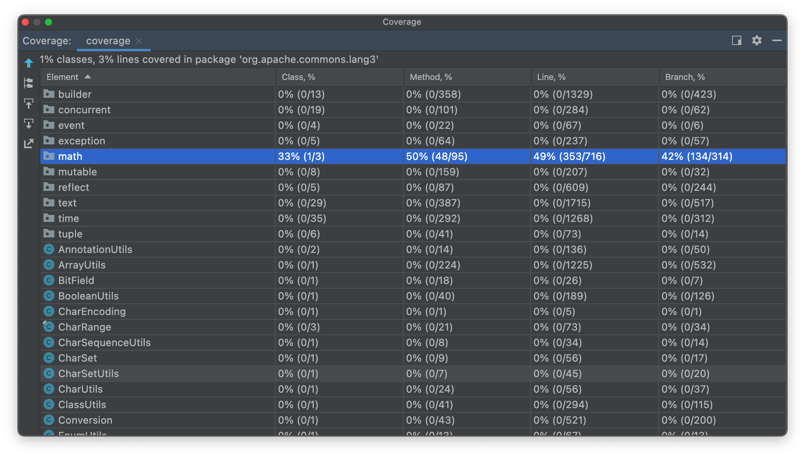

We created and executed a test suite specifically for math/NumberUtils. Looking at the picture above, we can see that coverage of the NumberUtils class is much higher than that of other classes. Nevertheless, it is actually not a very high value of 68%.

**﹅ Bug :**

✔︎ Red line is buggy version, green line is fixed version

The createBigDecimal method is a method that converts String into a BigDecimal number and returns it. The CreateNumber checks that given string start with '--', and returns null if found. This is a solution for a bug in BigDecimal that the string starting with '--' is not a number. But it should be throw exception likes other mothods. And also, should be move to createBigDecimal for checked all of the BigDecimal case.

**﹅ Bug-revealing test :** Tests run: 146, Failures: 2, Errors: 0, Skipped: 0

**1. NumberUtils_ESTest.test106**

➜ java.lang.AssertionError: Exception was not thrown in org.apache.commons.lang3.math.NumberUtils but in java.math.BigDecimal.<init>(BigDecimal.java:553): java.lang.NumberFormatException

at org.evosuite.runtime.EvoAssertions.assertThrownBy(EvoAssertions.java:112)

at org.evosuite.runtime.EvoAssertions.verifyException(EvoAssertions.java:49)

at org.apache.commons.lang3.math.NumberUtils_ESTest.test106(NumberUtils_ESTest.java:1904)

@Test(timeout = 4000)  
public void test106() throws Throwable {  
 float[] floatArray0 = new float[5];  
 floatArray0[0] = (-387.2784F);  
 floatArray0[1] = 271.4187F;  
 floatArray0[2] = (-4066.772F);  
 floatArray0[3] = 1.0F;  
 floatArray0[4] = 0.0F;  
 NumberUtils.*max*(floatArray0);  
 NumberUtils.*min*(0.0F, 645.99F, 271.4187F);  
 double[] doubleArray0 = new double[7];  
 doubleArray0[0] = (double) 271.4187F;  
 doubleArray0[1] = (-1202.92496144487);  
 doubleArray0[2] = (double) 0.0F;  
 doubleArray0[3] = (double) (-4066.772F);  
 doubleArray0[4] = (double) (-387.2784F);  
 doubleArray0[5] = 0.0;  
 doubleArray0[6] = (double) 271.4187F;  
 NumberUtils.*min*(doubleArray0);  
 NumberUtils.*toLong*("-0XThe Array must not be null");  
 NumberUtils.*isNumber*("---0XrBmFL<%*%YC0Dv|k\"");  
 NumberUtils.*toShort*("-0XThe Array must not be null");  
 // Undeclared exception!  
 try {   
 NumberUtils.*createBigDecimal*("---0XrBmFL<%*%YC0Dv|k\"");  
 *fail*("Expecting exception: NumberFormatException");  
   
 } catch(NumberFormatException e) {  
 //  
 // ---0XrBmFL<%*%YC0Dv|k\" is not a valid number.  
 //  
 *verifyException*("org.apache.commons.lang3.math.NumberUtils", e);  
 }  
}

We wanted to test the functions of the NumberUtils class using the various types of numbers, and to confirm that transfer the invalid string value (start with '--') to a number would be throw NumberFormatException in createBigDecimal. But in this code, exception was thrown in basic class of java, not in createBigDecimal of Lang7. Because createBigDecimal method doesn’t have any handle of this invalid string value case.

**2. NumberUtils_ESTest.test142**

➜ java.lang.AssertionError: Expecting exception: NumberFormatException

at org.apache.commons.lang3.math.NumberUtils_ESTest.test142(NumberUtils_ESTest.java:2624)

@Test(timeout = 4000)  
public void test142() throws Throwable {  
 short[] shortArray0 = new short[4];  
 shortArray0[0] = (short) (-9334);  
 shortArray0[1] = (short)48;  
 shortArray0[2] = (short)1869;  
 shortArray0[3] = (short) (-2239);  
 NumberUtils.*max*(shortArray0);  
 int[] intArray0 = new int[1];  
 intArray0[0] = (int) (short)1869;  
 NumberUtils.*min*(intArray0);  
 int[] intArray1 = new int[4];  
 intArray1[0] = (int) (short) (-9334);  
 intArray1[1] = (int) (short) (-9334);  
 intArray1[2] = (int) (short) (-9334);  
 intArray1[3] = (int) (short)1869;  
 NumberUtils.*max*(intArray1);  
 String string0 = "---";  
 NumberUtils.*toInt*("---");  
 byte[] byteArray0 = new byte[3];  
 byteArray0[0] = (byte)64;  
 byteArray0[2] = (byte)16;  
 NumberUtils.*max*(byteArray0);  
 NumberUtils.*min*(shortArray0);  
 try {   
 NumberUtils.*createNumber*("---");  
 *fail*("Expecting exception: NumberFormatException");  
   
 } catch(NumberFormatException e) {  
 //  
 // --- is not a valid number.  
 //  
 *verifyException*("org.apache.commons.lang3.math.NumberUtils", e);  
 }  
}

In this test, given string is start with '--'. So in CreateNumber method, it will be return null. And it makes NumberFormatException.

**[ Math_15 ]**

**﹅ Buggy Class :** org.apache.commons.math3.util.FastMath

**﹅ Branch Coverage :** 87.22891566265061% ➜ 87.46987951807229% (after modify)

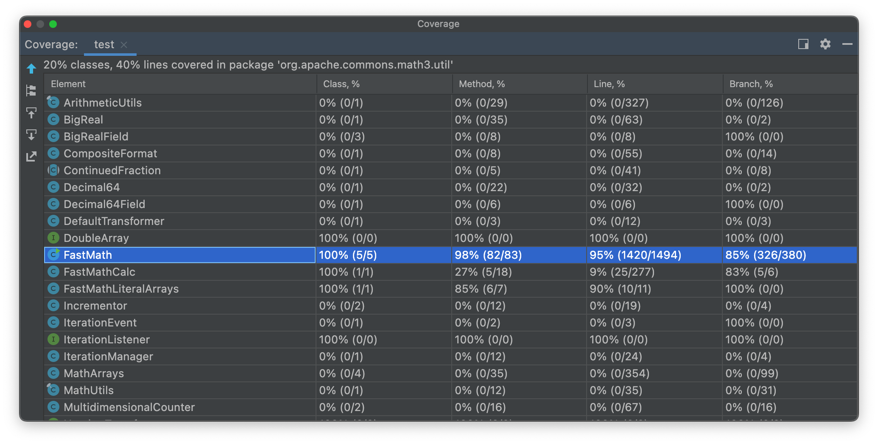

We created and executed a test suite specifically for util/FastMath. Looking at the picture above, we can see that coverage of the FastMath class is much higher than that of other classes. And it has a high value of 85%.

**﹅ Bug :**

✔︎ Red line is buggy version, green line is fixed version

The Pow is a method that returns the result of a power function with a given double number x is base and double number y is exponent. In IEEE 754, the frac of double precision is 52 bits. So, range of double precision is [-253, +253] because frac has one free bit (higher one true bit doesn’t present). If it’s out of range, it will be rounded to a multiple of two powers ( ex. (253, 254] ➜ 254 ) and it is even number. We want to handle it differently depending on whether y is an even integer or odd integer when x is negative. Therefore, the line 1541 should be TWO_POWER_53, not TWO_POWER_52. In this code, if y is odd integer in range [252, 253), it will return invalid value that pow(-x, y) instead of -pow(x, y). And if y is neither integer nor special value in range [252, 253), it will also return invalid value that pow(-x, y) instead of Double.NaN.

**﹅ Bug-revealing test :** Fail to generate a bug-revealing test. So I modify one of the generated test. As I mentioned before, if exponent is odd integer in range [252, 253) when base is negative, it will return invalid value that pow(-x, y) instead of -pow(x, y). So, I add that case.

**1. FastMath_ESTest.test131 (modify!)**

➜ java.lang.AssertionError: expected:<-Infinity> but was:<Infinity>

at org.junit.Assert.fail(Assert.java:88)

at org.junit.Assert.failNotEquals(Assert.java:834)

at org.junit.Assert.assertEquals(Assert.java:553)

at org.junit.Assert.assertEquals(Assert.java:683)

at org.apache.commons.math3.util.FastMath_ESTest.test131(FastMath_ESTest.java:12441)

@Test(timeout = 4000)  
public void test131() throws Throwable {  
 double double0 = FastMath.*pow*(-3.0, 4503599627370497.0);  
 double double1 = FastMath.*pow*(-3.0, 4503599627370495.0);  
 *assertEquals*(double1 * 9, double0, 0.01);  
}

In this test, both double0 and double1 bases are -3 that negative number. Exponent of double0 is 4503599627370497.0 (= (-3)2^52 + 1 = (-3)2 * (-3)2^52 - 1) that odd integer in range [252, 253). We expected the result to be same as the double1 which has exponent is 4503599627370495.0 (= (-3)2^52 - 1). But exponent of double0 in range [252, 253). So it goes into the if statement in line 1541 and return not corret value pow(-x, y). And double1 is return correct value -pow(x, y).

**[ Time_8 ]**

**﹅ Buggy Class :** org.joda.time.DateTimeZone

**﹅ Branch Coverage :** 80.48780487804879% (in statistics.csv)

We created and executed a test suite specifically for util/FastMath. Looking at the picture above, we can see that coverage of the FastMath class is much higher than that of other classes. Nevertheless, it is actually not a very high value of 68%.

**﹅ Bug :**

✔︎ Red line is buggy version, green line is fixed version

The forOffsetHourMinutes method is gets a time zone instance for the specified offset to UTC. In UTC notation, negative(-) means slower than standard time. And of course, minutes can be negative when hour is negative. When hour is negative, it means that time is as slow as the sum of the absolute value of hour and minute. ex) -15h, -30m ➜ It’s 15:30 slower. -15h, 30m ➜ It’s 15:30 slower too. So, even if the minute is negative, it should be allowed. And we should be handled the case that both hour and minute are negative. At now, forOffsetHourMinutes method should have thrown a IllegalArgumentException when minutesOffset is negative.

**﹅ Bug-revealing test :** Tests run: 81, Failures: 2, Errors: 2, Skipped: 0

**1. test56(org.joda.time.DateTimeZone_ESTest)**

➜ org.evosuite.runtime.mock.java.lang.MockIllegalArgumentException: Minutes out of range: -1

at org.joda.time.DateTimeZone.forOffsetHoursMinutes(DateTimeZone.java:280)

at org.joda.time.DateTimeZone_ESTest.test56(DateTimeZone_ESTest.java:3269)

@Test(timeout = 4000)  
public void test56() throws Throwable {  
 DateTimeZone dateTimeZone0 = DateTimeZone.*forOffsetHoursMinutes*((-1), (-1));  
 *assertNotNull*(dateTimeZone0);  
 *assertEquals*("-01:01", dateTimeZone0.getID());  
 *assertEquals*("-01:01", dateTimeZone0.toString());  
 *assertTrue*(dateTimeZone0.isFixed());  
   
 int int0 = dateTimeZone0.*UTC*.getOffsetFromLocal((-1));  
 *assertEquals*(0, int0);  
 *assertEquals*("-01:01", dateTimeZone0.getID());  
 *assertEquals*("-01:01", dateTimeZone0.toString());  
 *assertTrue*(dateTimeZone0.isFixed());  
   
 TimeZone timeZone0 = dateTimeZone0.toTimeZone();  
 *assertNotNull*(timeZone0);  
 *assertEquals*("-01:01", dateTimeZone0.getID());  
 *assertEquals*("-01:01", dateTimeZone0.toString());  
 *assertTrue*(dateTimeZone0.isFixed());  
 *assertEquals*("GMT-01:01", timeZone0.getID());  
   
 long long0 = dateTimeZone0.*UTC*.convertUTCToLocal(100L);  
 *assertEquals*(100L, long0);  
 *assertEquals*("-01:01", dateTimeZone0.getID());  
 *assertEquals*("-01:01", dateTimeZone0.toString());  
 *assertTrue*(dateTimeZone0.isFixed());  
   
 boolean boolean0 = dateTimeZone0.isFixed();  
 *assertTrue*(boolean0);  
 *assertEquals*("-01:01", dateTimeZone0.getID());  
 *assertEquals*("-01:01", dateTimeZone0.toString());  
 *assertTrue*(dateTimeZone0.isFixed());  
   
 DateTimeZone dateTimeZone1 = DateTimeZone.*forTimeZone*(timeZone0);  
 *assertNotNull*(dateTimeZone1);  
 *assertEquals*("-01:01", dateTimeZone0.getID());  
 *assertEquals*("-01:01", dateTimeZone0.toString());  
 *assertTrue*(dateTimeZone0.isFixed());  
 *assertEquals*("GMT-01:01", timeZone0.getID());  
 *assertTrue*(dateTimeZone1.isFixed());  
 *assertEquals*("-01:01", dateTimeZone1.getID());  
 *assertEquals*("-01:01", dateTimeZone1.toString());  
 *assertSame*(dateTimeZone0, dateTimeZone1);  
 *assertSame*(dateTimeZone1, dateTimeZone0);  
   
 String string0 = dateTimeZone0.getNameKey(0L);  
 *assertNull*(string0);  
 *assertEquals*("-01:01", dateTimeZone0.getID());  
 *assertEquals*("-01:01", dateTimeZone0.toString());  
 *assertTrue*(dateTimeZone0.isFixed());  
 *assertSame*(dateTimeZone0, dateTimeZone1);  
   
 long long1 = dateTimeZone0.adjustOffset((-2153L), false);  
 *assertEquals*((-2153L), long1);  
 *assertEquals*("-01:01", dateTimeZone0.getID());  
 *assertEquals*("-01:01", dateTimeZone0.toString());  
 *assertTrue*(dateTimeZone0.isFixed());  
 *assertSame*(dateTimeZone0, dateTimeZone1);  
 *assertFalse*(long1 == long0);  
   
 LinkedList<Locale.LanguageRange> linkedList0 = new LinkedList<Locale.LanguageRange>();  
 *assertNotNull*(linkedList0);  
 *assertEquals*(0, linkedList0.size());  
   
 LinkedList<Locale.LanguageRange> linkedList1 = new LinkedList<Locale.LanguageRange>();  
 *assertNotNull*(linkedList1);  
 *assertEquals*(0, linkedList1.size());  
 *assertTrue*(linkedList1.equals((Object)linkedList0));  
}

In this test, we expected to create a DateTimeZone with a value of “-01:01” and apply several functions to it and verify it’s correctness. But in the highlighted line, the minutesOffset is negative (-1). So, it goes into the if statement in line 279 of the forOffsetHourMinutes method, and throws an IllegalArgumentException.

**2. test59(org.joda.time.DateTimeZone_ESTest)**

➜ org.evosuite.runtime.mock.java.lang.MockIllegalArgumentException: Minutes out of range: -23

at org.joda.time.DateTimeZone.forOffsetHoursMinutes(DateTimeZone.java:280)

at org.joda.time.DateTimeZone_ESTest.test59(DateTimeZone_ESTest.java:3466)

@Test(timeout = 4000)  
public void test59() throws Throwable {  
 BuddhistChronology buddhistChronology0 = BuddhistChronology.*getInstanceUTC*();  
 *assertEquals*(1, BuddhistChronology.*BE*);  
 *assertNotNull*(buddhistChronology0);  
   
 DateTimeZone dateTimeZone0 = DateTimeZone.*forOffsetHoursMinutes*((-23), (-23));  
 *assertNotNull*(dateTimeZone0);  
 *assertEquals*("-23:23", dateTimeZone0.toString());  
 *assertTrue*(dateTimeZone0.isFixed());  
 *assertEquals*("-23:23", dateTimeZone0.getID());  
}

In this test, we expected to create a DateTimeZone with a value of “-23:23” and apply several functions to it and verify it’s correctness. But in the highlighted line, the minutesOffset is negative (-23). So, it goes into the if statement in line 279 of the forOffsetHourMinutes method, and throws an IllegalArgumentException.

**﹅ Conclusion**

I have created many programs, but this was the first time I had used a test generator to check it’s correctness. It is difficult to test as the code gets longer and more complicated, but using EvoSuite, it was convenient to generate a test with a simple command in the direction of automatically increasing branch coverage. And using EvoSuite, I found some interesting things.

In the Math8 package, ran a test on FastMath, a class for fast and accurate calculations. and I found that variables with values appeared in other test suites.

|  |  |
| --- | --- |
| @Test(timeout = 4000) public void test000() throws Throwable {  double double0 = FastMath.*floor*(3.4893601256685762E283);  *assertEquals*(3.4893601256685762E283, double0, 0.01);    double double1 = FastMath.*exp*(3.7072473866919033E-183);  *assertNotEquals*(double1, double0, 0.01);  *assertEquals*(1.0, double1, 0.01);    double double2 = FastMath.*sqrt*(3.7072473866919033E-183);  *assertNotEquals*(double2, double1, 0.01);  *assertNotEquals*(double2, double0, 0.01);  *assertEquals*(6.088716931088112E-92, double2, 0.01);    double double3 = FastMath.*abs*(0.07419405760538333);  *assertNotEquals*(double3, double0, 0.01);  *assertNotEquals*(double3, double1, 0.01);  *assertNotEquals*(double3, double2, 0.01);  *assertEquals*(0.07419405760538333, double3, 0.01);    float float0 = FastMath.*nextUp*(1623.06F);  *assertEquals*(1623.0602F, float0, 0.01F);  …  } | @Test(timeout = 4000) public void test130() throws Throwable {  FastMath.*floor*(3.4893601256685762E283);  FastMath.*exp*(3.7072473866919033E-183);  FastMath.*sqrt*(3.7072473866919033E-183);  FastMath.*abs*(3.7072473866919033E-183);  float float0 = FastMath.*nextUp*(1623.06F);  *assertEquals*(1623.0602F, float0, 0.01F);    double double0 = FastMath.*sin*(1623.06F);  *assertEquals*(0.9100245640753561, double0, 0.01);    float float1 = FastMath.*min*((-2933.0F), 1623.0602F);  …  } |

The above is the code of test000 and test130. If you look closely at the code, you can see that three numbers 3.4893601256685762E283, 3.7072473866919033E-183, and 1623.0602F overlap despite different tests. I think this is a characteristic of EvoSuite using the evolution generate method that mutates the randomly generated population at the beginning. In EvoSuite, test suites are heavily influenced by initial population. In the process of selecting the seed test and mutating the selected tests using various mutation operators such as AOR and ROR COR, the test was created while some of the values were maintained.

However, there were cases in Math15 where the bug could not be found even if the best test suite was generated after several mutates. I think this is because EvoSuite is a Whitebox test. In other words, since it is a structure-based test, the purpose is only to increase coverage. Therefore, it is not interested in whether all functions operate normally. Just terminating the test generation as soon as the coverage goal is exceeded. Actually, Class, Method, and Line coverage is over then 95%, and also branch coverage is 87% but it failed to find bug.





In addition, if the bug is very unlikely (with a small range of bugs), no matter how random the test is, it may not be possible to generate a test that finds bugs. A bug in the Math15 class occurs only when a given argument is in a specific range that [252, 253), which occurs in the pow(x, y) method. Considering the range of numbers that can be expressed in 64 bits, and probability of using the buggy class method in the test, the probability of finding a bug is even lower., it can be seen that this is very unlikely to occur. Through this example, we learned that simply increasing the coverage of the test does not necessarily mean that it is effective.

Although the test suite was created in the fixed Time8 package, 2 tests were failed regardless of whether they were fixed or buggy versions. In both tests, the DataTimeZone provider was set to UTCProvider, but it was not set to UTC. I wanted to find out the cause of this, but I have not yet revealed it. Below is the failed test code and message.

**1. test01(org.joda.time.DateTimeZone_ESTest)**

➜ org.junit.ComparisonFailure: expected:<[UTC]> but was:<[Asia/Seoul]>

at org.junit.Assert.assertEquals(Assert.java:115)

at org.junit.Assert.assertEquals(Assert.java:144)

at org.joda.time.DateTimeZone_ESTest.test01(DateTimeZone_ESTest.java:103)

@Test(timeout = 4000)  
public void test01() throws Throwable {  
 boolean boolean0 = FileSystemHandling.*shouldThrowIOException*((EvoSuiteFile) null);  
 *assertFalse*(boolean0);  
   
 UTCProvider uTCProvider0 = new UTCProvider();  
 *assertNotNull*(uTCProvider0);  
   
 Set<String> set0 = uTCProvider0.getAvailableIDs();  
 *assertNotNull*(set0);  
 *assertEquals*(1, set0.size());  
 *assertFalse*(set0.isEmpty());  
   
 Set<String> set1 = uTCProvider0.getAvailableIDs();  
 *assertNotNull*(set1);  
 *assertEquals*(1, set1.size());  
 *assertFalse*(set1.isEmpty());  
 *assertNotSame*(set1, set0);  
 *assertTrue*(set1.equals((Object)set0));  
   
 DateTimeZone.*setProvider*(uTCProvider0);  
 DateTimeZone dateTimeZone0 = DateTimeZone.*getDefault*();  
 *assertNotNull*(dateTimeZone0);  
 *assertEquals*("UTC", dateTimeZone0.getID());  
 *assertEquals*("UTC", dateTimeZone0.toString());  
 *assertTrue*(dateTimeZone0.isFixed());  
   
 Locale locale0 = Locale.*GERMAN*;  
 *assertNotNull*(locale0);  
 *assertEquals*("de", locale0.toString());  
 *assertEquals*("deu", locale0.getISO3Language());  
 *assertEquals*("de", locale0.getLanguage());  
 *assertEquals*("", locale0.getCountry());  
 *assertEquals*("", locale0.getISO3Country());  
 *assertEquals*("", locale0.getVariant());  
   
 DateTimeUtils.*setCurrentMillisSystem*();  
 String string0 = dateTimeZone0.getName(106109248L);  
 *assertEquals*("+00:00", string0);  
 *assertNotNull*(string0);  
 *assertEquals*("UTC", dateTimeZone0.getID());  
 *assertEquals*("UTC", dateTimeZone0.toString());  
 *assertTrue*(dateTimeZone0.isFixed());  
   
 String string1 = dateTimeZone0.getID();  
 *assertEquals*("UTC", string1);  
 *assertNotNull*(string1);  
 *assertEquals*("UTC", dateTimeZone0.getID());  
 *assertEquals*("UTC", dateTimeZone0.toString());  
 *assertTrue*(dateTimeZone0.isFixed());  
 *assertFalse*(string1.equals((Object)string0));  
   
 DateTimeZone dateTimeZone1 = DateTimeZone.*forOffsetMillis*(662);  
 *assertNotNull*(dateTimeZone1);  
 *assertEquals*("+00:00:00.662", dateTimeZone1.getID());  
 *assertEquals*("+00:00:00.662", dateTimeZone1.toString());  
 *assertTrue*(dateTimeZone1.isFixed());  
 *assertNotSame*(dateTimeZone1, dateTimeZone0);  
 *assertFalse*(dateTimeZone1.equals((Object)dateTimeZone0));  
   
 boolean boolean1 = dateTimeZone1.isStandardOffset((-2752832L));  
 *assertTrue*(boolean1);  
 *assertEquals*("+00:00:00.662", dateTimeZone1.getID());  
 *assertEquals*("+00:00:00.662", dateTimeZone1.toString());  
 *assertTrue*(dateTimeZone1.isFixed());  
 *assertNotSame*(dateTimeZone1, dateTimeZone0);  
 *assertFalse*(dateTimeZone1.equals((Object)dateTimeZone0));  
 *assertFalse*(boolean1 == boolean0);  
}

**2. test78(org.joda.time.DateTimeZone_ESTest)**

➜ java.lang.AssertionError: null

at org.junit.Assert.fail(Assert.java:86)

at org.junit.Assert.assertTrue(Assert.java:41)

at org.junit.Assert.assertTrue(Assert.java:52)

at org.joda.time.DateTimeZone_ESTest.test78(DateTimeZone_ESTest.java:5052)

@Test(timeout = 4000)  
public void test78() throws Throwable {  
 UTCProvider uTCProvider0 = new UTCProvider();  
 *assertNotNull*(uTCProvider0);  
   
 Set<String> set0 = uTCProvider0.getAvailableIDs();  
 *assertNotNull*(set0);  
 *assertEquals*(1, set0.size());  
 *assertFalse*(set0.isEmpty());  
   
 Set<String> set1 = uTCProvider0.getAvailableIDs();  
 *assertNotNull*(set1);  
 *assertEquals*(1, set1.size());  
 *assertFalse*(set1.isEmpty());  
 *assertNotSame*(set1, set0);  
 *assertTrue*(set1.equals((Object)set0));  
   
 DateTimeZone.*setProvider*(uTCProvider0);  
 DateTimeZone dateTimeZone0 = DateTimeZone.*getDefault*();  
 *assertNotNull*(dateTimeZone0);  
 *assertTrue*(dateTimeZone0.isFixed());  
 *assertEquals*("UTC", dateTimeZone0.toString());  
 *assertEquals*("UTC", dateTimeZone0.getID());  
   
 Locale locale0 = Locale.*GERMAN*;  
 *assertNotNull*(locale0);  
 *assertEquals*("deu", locale0.getISO3Language());  
 *assertEquals*("", locale0.getCountry());  
 *assertEquals*("de", locale0.toString());  
 *assertEquals*("", locale0.getVariant());  
 *assertEquals*("de", locale0.getLanguage());  
 *assertEquals*("", locale0.getISO3Country());  
   
 DateTimeUtils.*setCurrentMillisSystem*();  
 String string0 = dateTimeZone0.getName(106109248L);  
 *assertEquals*("+00:00", string0);  
 *assertNotNull*(string0);  
 *assertTrue*(dateTimeZone0.isFixed());  
 *assertEquals*("UTC", dateTimeZone0.toString());  
 *assertEquals*("UTC", dateTimeZone0.getID());  
   
 String string1 = dateTimeZone0.getID();  
 *assertEquals*("UTC", string1);  
 *assertNotNull*(string1);  
 *assertTrue*(dateTimeZone0.isFixed());  
 *assertEquals*("UTC", dateTimeZone0.toString());  
 *assertEquals*("UTC", dateTimeZone0.getID());  
 *assertFalse*(string1.equals((Object)string0));  
   
 DateTimeZone dateTimeZone1 = DateTimeZone.*forOffsetMillis*(662);  
 *assertNotNull*(dateTimeZone1);  
 *assertEquals*("+00:00:00.662", dateTimeZone1.toString());  
 *assertTrue*(dateTimeZone1.isFixed());  
 *assertEquals*("+00:00:00.662", dateTimeZone1.getID());  
 *assertNotSame*(dateTimeZone1, dateTimeZone0);  
 *assertFalse*(dateTimeZone1.equals((Object)dateTimeZone0));  
   
 boolean boolean0 = dateTimeZone1.isStandardOffset((-2752832L));  
 *assertTrue*(boolean0);  
 *assertEquals*("+00:00:00.662", dateTimeZone1.toString());  
 *assertTrue*(dateTimeZone1.isFixed());  
 *assertEquals*("+00:00:00.662", dateTimeZone1.getID());  
 *assertNotSame*(dateTimeZone1, dateTimeZone0);  
 *assertFalse*(dateTimeZone1.equals((Object)dateTimeZone0));  
   
 Set<String> set2 = DateTimeZone.*getAvailableIDs*();  
 *assertNotNull*(set2);  
 *assertEquals*(1, set2.size());  
 *assertFalse*(set2.isEmpty());  
 *assertTrue*(set2.contains(string1));  
 *assertFalse*(set2.contains(string0));  
   
 DateTimeZone dateTimeZone2 = DateTimeZone.*forOffsetMillis*(662);  
 *assertNotNull*(dateTimeZone2);  
 *assertEquals*("+00:00:00.662", dateTimeZone2.toString());  
 *assertTrue*(dateTimeZone2.isFixed());  
 *assertEquals*("+00:00:00.662", dateTimeZone2.getID());  
 *assertNotSame*(dateTimeZone2, dateTimeZone0);  
 *assertSame*(dateTimeZone2, dateTimeZone1);  
 *assertFalse*(dateTimeZone2.equals((Object)dateTimeZone0));  
   
 String string2 = dateTimeZone0.getShortName((-996L), locale0);  
 *assertEquals*("+00:00", string2);  
 *assertNotNull*(string2);  
 *assertTrue*(dateTimeZone0.isFixed());  
 *assertEquals*("UTC", dateTimeZone0.toString());  
 *assertEquals*("UTC", dateTimeZone0.getID());  
 *assertEquals*("deu", locale0.getISO3Language());  
 *assertEquals*("", locale0.getCountry());  
 *assertEquals*("de", locale0.toString());  
 *assertEquals*("", locale0.getVariant());  
 *assertEquals*("de", locale0.getLanguage());  
 *assertEquals*("", locale0.getISO3Country());  
 *assertNotSame*(dateTimeZone0, dateTimeZone2);  
 *assertNotSame*(dateTimeZone0, dateTimeZone1);  
 *assertFalse*(dateTimeZone0.equals((Object)dateTimeZone2));  
 *assertFalse*(dateTimeZone0.equals((Object)dateTimeZone1));  
 *assertTrue*(string2.equals((Object)string0));  
 *assertFalse*(string2.equals((Object)string1));  
   
 dateTimeZone0.hashCode();  
 *assertTrue*(dateTimeZone0.isFixed());  
 *assertEquals*("UTC", dateTimeZone0.toString());  
 *assertEquals*("UTC", dateTimeZone0.getID());  
 *assertNotSame*(dateTimeZone0, dateTimeZone2);  
 *assertNotSame*(dateTimeZone0, dateTimeZone1);  
 *assertFalse*(dateTimeZone0.equals((Object)dateTimeZone2));  
 *assertFalse*(dateTimeZone0.equals((Object)dateTimeZone1));  
}